**MATLAB code Week 4**

**Integration: Indefinite, definite and Area between the curves**

**MATLAB Syntax used**:

|  |  |
| --- | --- |
| int(f,v) | uses the symbolic object v as the variable of integration, rather than the variable determined by symvar |
| rsums(f, [a, b]) | rsums(f, a, b) and rsums(f, [a, b]) approximates the integral for *x* from a to b. |
| fill(X,Y,C) | fill(X,Y,C) creates filled polygons from the data in X and Y with vertex color specified by C. |
| char(X) | converts array X of nonnegative integer codes into a character array. |

1. **Integration**
2. **Inbuilt MATLAB function:**

syms x

f=input('enter the function f(x):');

a=input('enter lower limit of x ');

b=input('enter the upper limit of x');

n=input('number of intervals');

z=int(f,a,b) % direct evaluation

1. **As a sum of rectangles by using rsums command :**

🡪**Initialization:**

value = 0;

dx = (b-a)/n;

**🡪 sum of the function values at all the right points**

for k=1:n

c = a+k*dx;

d=subs(f,x,c);

value = value + d;

end

**🡪 value of the sum* length of the sub interval is the approx. value of the integral**

ivalue = dx*value

ezplot(f,[a b])

**🡪 Taking mid point function values**

rsums(f, a, b)

**Problems:**

1. Sin(x) in [0, 2 pi]

**Output**

enter the function f(x):sin(x)

                   enter lower limit of x 0

                   enter the upper limit of x2*pi

                    number of intervals10

                    z =

                    0

                    value =

                    -1.5389e-016

                     z =

                    0

Figure Window:

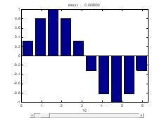

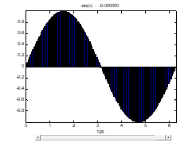

1. Cos(x) in [-pi/2, pi/2]

**Output**

enter the function f(x):

cos(x)

enter lower limit of x

-pi/2

enter the upper limit of x

pi/2

number of intervals

10

z =  
   
2

value =  
   
(pi*((2^(1/2)*(5 - 5^(1/2))^(1/2))/2 + 5^(1/2) + (2^(1/2)*(5^(1/2) + 5)^(1/2))/2 + 1))/10

z =  
   
2

Figure Window:

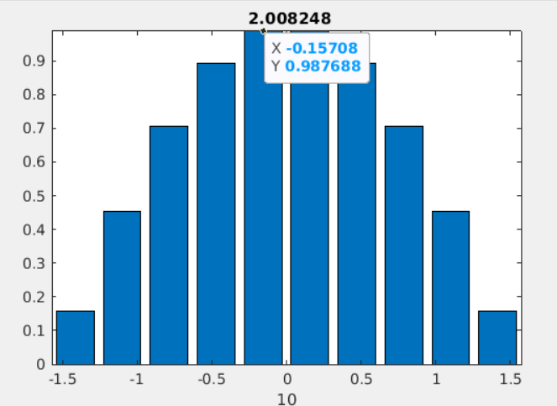

1. e^x+tan(x)

**Output**

enter the function f(x):

exp(x)+tan(x)

enter lower limit of x

0

enter the upper limit of x

pi/4

number of intervals

10

z =  
   
exp(pi/4) + log(2)/2 - 1

value =  
   
(pi*(exp(pi/4) + exp(pi/5) + exp(pi/8) + exp(pi/10) + exp(pi/20) + exp((3*pi)/20) + exp(pi/40) + exp((3*pi)/40) + exp((7*pi)/40) + exp((9*pi)/40) + tan(pi/20) + tan((3*pi)/20) + tan(pi/40) + tan((3*pi)/40) + tan((7*pi)/40) + tan((9*pi)/40) + (5^(1/2)*(5 - 2*5^(1/2))^(1/2))/5 + 2^(1/2) + (5 - 2*5^(1/2))^(1/2)))/40

z =  
   
exp(pi/4) + log(2)/2 - 1

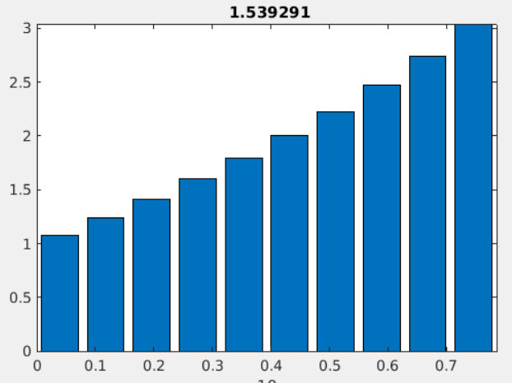

1. **Area between the curves:**

clc

clear all

close all

syms x

y1=input('ENTER THE Y1 REGION VALUE');

y2=input('ENTER THE Y2 REGION VALUE');

t=solve(y1-y2); %(Y1-Y2=0)

po=double(t)

poi=sort(po)

n=length(poi)

m1=min(poi)

m2=max(poi)

ez1=ezplot(y1,[m1-1,m2+1])

hold on

TA=0

ez2=ezplot(y2,[m1-1,m2+1])

if n>2

for i=1:n-1

A=int(y1-y2,poi(i),poi(i+1))

TA= TA+abs(A)

x1 = linspace(poi(i),poi(i+1))

yy1 =subs(y1,x,x1)

yy2 = subs(y2,x,x1)

%iii) Creating a polygon:

xx = [x1,fliplr(x1)]

yy = [yy1,fliplr(yy2)]

fill(xx,yy,'g')

grid on

end

else

A=int(y1-y2,poi(1),poi(2))

TA=abs(A)

x1 = linspace(poi(1),poi(2));

yy1 =subs(y1,x,x1)

yy2 = subs(y2,x,x1)

xx = [x1,fliplr(x1)]

yy = [yy1,fliplr(yy2)]

fill(xx,yy,'g')

end

**Problems:**

1. Find the area of the regions enclosed by the curves,

**Output**

ENTER THE Y1 REGION VALUE

x

ENTER THE Y2 REGION VALUE

x^2-2*x

f =  
   
9/2  
   
kokler =  
  
 0  
 3

f =  
9/2

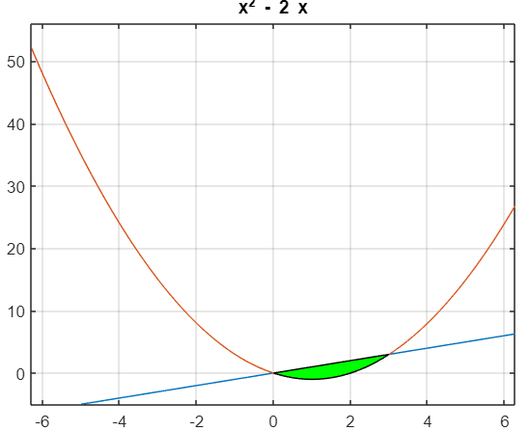

1. Find the area of the regions enclosed by the curves 𝑦 = 𝑥4 − 4𝑥2 + 4, 𝑦 = 𝑥2

**Output:**

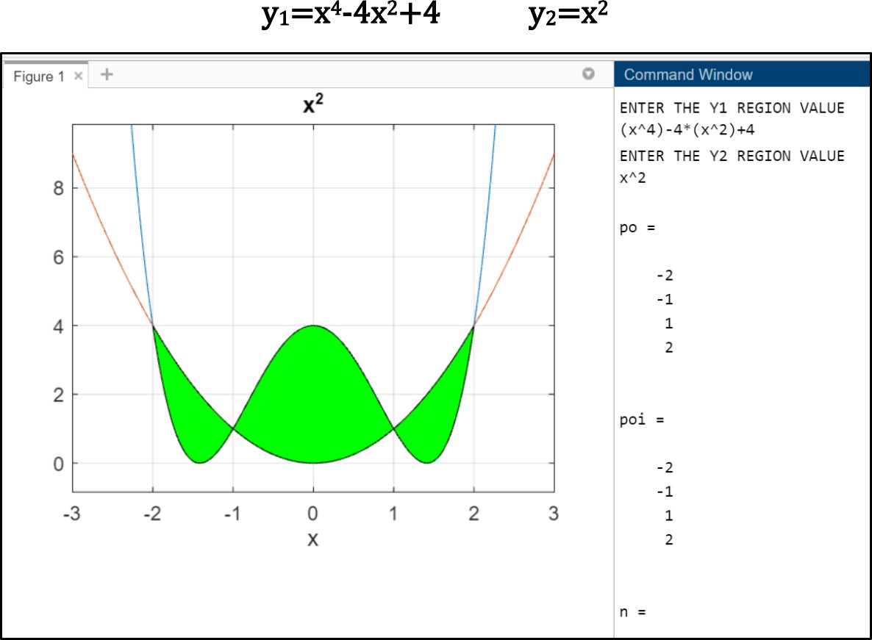

**MATLAB code Week 5**

# Volume of Solid of Revolution

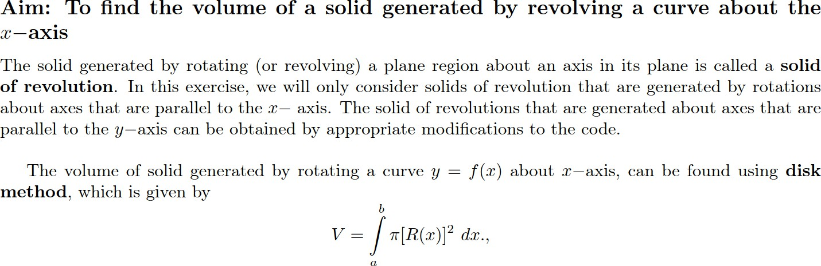

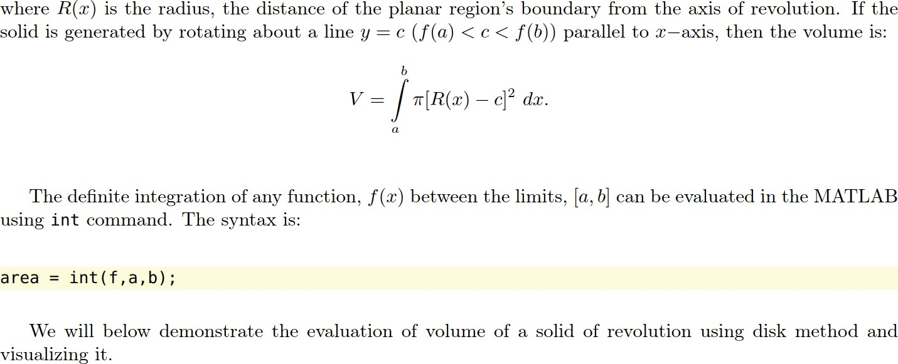

clc clear all close all

%%

syms x;

f = input('Enter the function: ');

fL = input('Enter the interval on which the function is defined: '); yr = input('Enter the axis of rotation y = c (enter only c value): '); iL = input('Enter the integration limits: ');

Volume = pi*int((f-yr)^2,iL(1),iL(2)); sprintf('Volume is %3f ', double(Volume))

%% Shading the area between the axis of rot. and function fx = inline(vectorize(f));

xvals = linspace(fL(1),fL(2),201); xvalsr = fliplr(xvals);

xivals = linspace(iL(1),iL(2),201); xivalsr = fliplr(xivals);

xlim = [fL(1) fL(2)+0.5];

ylim = fx(xlim); figure('Position',[100 200 560 420]) subplot(2,1,1)

hold on;

plot(xvals,fx(xvals),'k-','LineWidth',2); plot([fL(1) fL(2)],[yr yr],'r-','LineWidth',2);

fill([xivals xivalsr],[fx(xivals) ones(size(xivalsr))*yr],[0.8 0.8 0.8],'FaceAlpha',0.8)

%% Marking the axis

%plot([fL(1) fL(2)],[yr yr],'r-','LineWidth',2);

legend('Function Plot','Axis of Rotation', 'Filled Region','Location','Best'); title('Function y=f(x) and Region');

set(gca,'XLim',xlim) xlabel('x−axis'); ylabel('y−axis');

%% Plotting reflection of the curve about the axis of rot subplot(2,1,2)

hold on;

plot(xivals,fx(xivals),'b-','LineWidth',2); plot([iL(1) iL(2)],[yr yr],'r-','LineWidth',2);

fill([xivals xivalsr],[fx(xivals) ones(size(xivalsr))*yr],[0.8 0.8 0.8],'FaceAlpha',0.8)

plot(xivals,-fx(xivals)+2*yr,'m-','LineWidth',2);

fill([xivals xivalsr],[ones(size(xivals))*yr -fx(xivalsr)+2*yr],[1 0.8 0.8],'FaceAlpha',0.8) title('Rotated Region in xy−Plane');

set(gca,'XLim',xlim) xlabel('x−axis'); ylabel('y−axis');

%% Solid

[X,Y,Z] = cylinder(fx(xivals)-yr,100); figure('Position',[700 200 560 420]) Z = iL(1) + Z.*(iL(2)-iL(1));

surf(Z,Y+yr,X,'EdgeColor','none','FaceColor','flat','FaceAlpha',0.6); hold on;

plot([iL(1) iL(2)],[yr yr],'r-','LineWidth',2); xlabel('X−axis');

ylabel('Y−axis'); zlabel('Z−axis'); view(21,11);

## Problems:

1. Find the volume of the solid generated by revolving the region bounded by 𝑦 =

√𝑥, 𝑜 ≤ 𝑥 ≤ 4 about the line 𝑦 = 1

### Output:

Enter the function:

sqrt(x)

Enter the interval on which the function is defined: [0 4]

Enter the axis of rotation y = c (enter only c value): 1

Enter the integration limits: [0 4]

ans =

'Volume is 4.188790e+00

|  |  |
| --- | --- |
|  |  |

1. Find the volume of the solid generated by revolving the region bounded by 𝑦 =

𝑠𝑖𝑛 𝑥, 𝑜 ≤ 𝑥 ≤ 𝜋 about the line 𝑦 = 𝑐, 𝑜 ≤ 𝑐 ≤ 1, 𝑐 = 0,0.2,0.4.0.6,0.8,1.0. Can you identify the range or exact value of c that minimize and maximize the volume of the solid?

### Output:

#### For C=0

Enter the function:

sin(x)

Enter the interval on which the function is defined: [0 pi]

Enter the axis of rotation y = c (enter only c value): 0

Enter the integration limits:

[0 pi] ans =

'Volume is 4.934802e+00 '

|  |  |
| --- | --- |
|  |  |

#### For c=0.2

Enter the function:

sin(x)

Enter the interval on which the function is defined: [0 pi]

Enter the axis of rotation y = c (enter only c value): 0.2

Enter the integration limits: [0 pi]

ans =

'Volume is 2.816312e+00 '

|  |  |
| --- | --- |
|  |  |

#### For c=0.4

f = sin(x)

fL =

yr =

0 3.1416

0.4000

iL =

0 3.1416

ans =

'Volume is 1.487391e+00 '

|  |  |
| --- | --- |
|  |  |

### For c=0.6

f = sin(x) fL =

0 3.1416

yr =

0.6000

iL =

0 3.1416

ans =

'Volume is 9.480374e-01 '

|  |  |
| --- | --- |
|  |  |

### For c=0.8

f = sin(x) fL =

0 3.1416

yr =

0.8000

iL =

0 3.1416

ans =

'Volume is 1.198253e+00 '

